Auto attendant
Link copied
- May 13, 2026
- 7 minutes to read

Basic concept
Link copied
- The Media Server’s auto attendant is composed of a set of menus.
- All the menus are identical in every respect, except for the ROOT menu, which is always present and cannot be deleted, and whose name cannot be changed.
- When a caller dials the system, auto attendant will answer (connect) the call and proceed to the ROOT menu.
- If a user tries to access a menu that is not currently active, the action specified in the When the menu is inactive, then configuration option will be performed; for instance, the user may be automatically forwarded to an "after hours" menu.
- The Intro prompt (e.g., "Welcome to PortaOne, a VoIP solutions company!") is played when a user enters a menu for the first time.
- After this, the Menu prompt will be played, listing all the available options (e.g., "Press 1 for sales, press 2 for technical support"), and auto attendant will collect the digits dialed by the user on his phone touchpad.
- If no input is received (timeout), the No input action is performed. If No input is not configured beforehand by the administrator, then the system plays the prompt about missed input and the dialog reverts to the previous step (e.g., plays the Menu prompt and collects the user’s input).
- The user’s input will be matched with the corresponding menu items, and the action associated with this item will be performed. The following actions are possible:
  - Do Nothing – performs no action. This option can be used to cancel the action that was previously used for the user’s input..
  - Transfer – transfers the call to a given telephone number or extension. The phone number should be entered in the same format as the customer would use to dial it from an IP phone in their cloud PBX environment; for example, to transfer a call to extension 123, simply enter 123.
  - Transfer to E.164 Number – transfers the call to a given number. The number should be specified in E.164 format: the country code, followed by the area code, and then the number (e.g., 16045551234 for Canada).
  - Prompt for extension # – this transfers the call to an extension number entered by the caller from his dialpad. For example, the menu item is 5 and the extension number is 123. When the voice prompt requests that the user input a menu item and then the extension number, the caller inputs 5123 and is connected with the callee.
  - Dial extension directly – this transfers the call to an extension number entered by the caller from his phone. Note that this option is only applicable if the first number of an extension coincides with the current action digit. For example, the menu item is 5 and the extension number is 5123. The voice prompt requests only the extension number to be input, so the caller inputs 5123 and is connected with the callee.
  - Transfer to Voicemail – switches to voicemail mode. This should be designated as an action for the "Fax" event, in order to allow storage of received faxes.
  - Dial-by-name directory – launches the company’s dial-by-name directory. This allows a caller to look up a person by using the first three letters of their extension name
  - Disconnect call – this disconnects a call. PBX customers can configure their auto attendant to play a prompt and disconnect a call when the menu is inactive or when the caller presses/does not press a key.
  - Menu – this transfers the user to the selected auto attendant menu.
  - DISA (Direct Inward System Access) – this asks the caller for their DISA password. If the DISA password entered is valid, the system facilitates the outgoing call.
  - Call Queue – this transfers the caller to the selected call queue.
- You may select whether the corresponding Before Action prompt is to be played prior to the action.
- A call menu flow chart is shown in the diagram below.
Call menu flow chart
Link copied
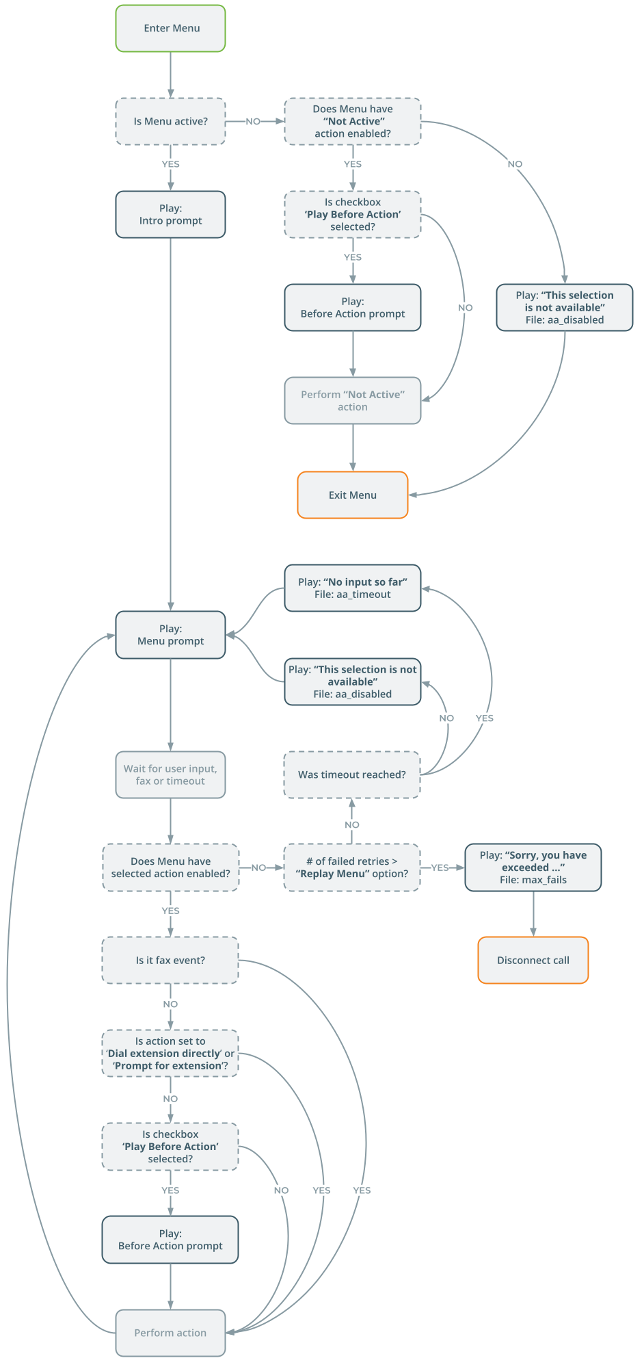
Detailed information on how to configure the auto attendant is provided in the Configuring Auto Attendant Functionality handbook.
Dial-by-name directory
Link copied
This is another element of the auto attendant IVR functionality. If a caller does not know the extension number of the person he is trying to reach, he can look up the party by using the first three letters of the party’s extension name.
The system only matches the first three letters written in the Extension Name field.
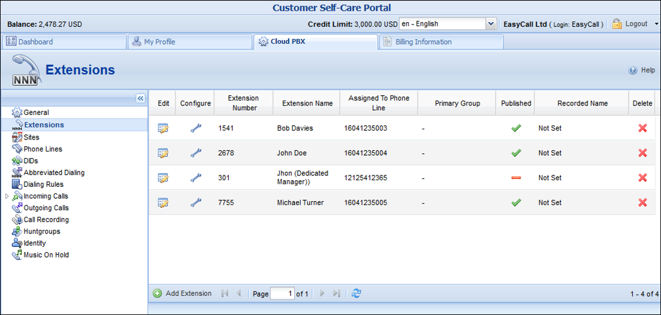
There is a single, unified dial-by-name directory for each cloud PBX environment. It is linked to the list of extensions, so when you create an extension, you can mark it "published" for it to be included in the dial-by-name directory and then upload correspondent voice prompts with the person’s name. You may also exclude certain extensions from being accessible via a dial-by-name (e.g., when you do not want telemarketers to directly reach your CEO or CFO because their names are publicly accessible).
The dial-by-name directory can be assigned as an "action" item to any element in the ROOT menu or sub-menu. When a user reaches the dial-by-name dialog, he will be prompted to enter the three first letters in the called party’s extension name. Standard phone mapping is used, e.g., 2 is ABC, 3 is DEF, and so on. If no matching person is found, the user is informed of this, and may then re-enter the name or press * to exit. If more than one match is found (e.g., there are two persons with the "same" name in the company, e.g., 526 will match both Jane and Kamila), the user will hear a list of matching names and their extensions, and may then enter the correct extension.
End users can replace a default dial-by-name directory’s voice prompt (which prompts a caller to enter the three first letters of the called party’s extension name) with a custom voice prompt on their self-care interfaces.
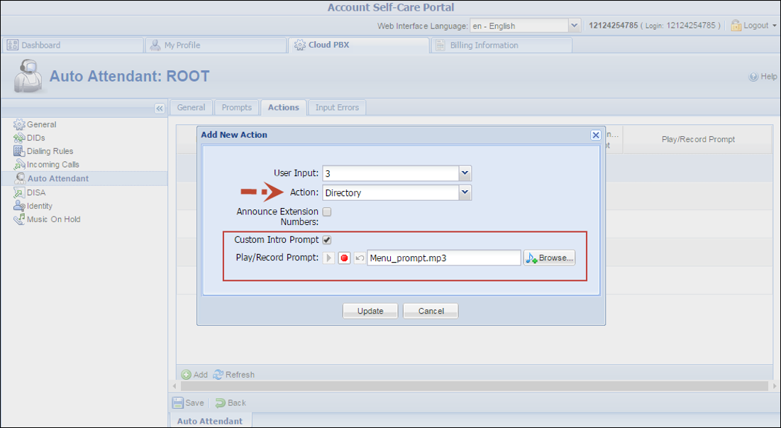
Direct access to extension from auto attendant
Link copied
In addition to the existing mode that requires an end user to select a "Dial extension" action first, you may set up direct dialing for the extension from the auto attendant. For example, when a customer wants to contact a personal manager, he dials the company’s corporate number (e.g., 18005559876) and the manager’s extension (e.g., 301, found on the manager’s business card). The customer dials 18005559876 from his mobile and reaches the corporate menu, which offers to initiate a call with, e.g., sales by pressing "1," or the support dept. by pressing "2" or by directly dialing the extension. The customer may now dial "301" without having to listen to all of the options and the call to his manager will be immediately initiated. If the manager is unavailable, the call may be redirected to voicemail (if such an option is activated).
To configure the direct access to extension from auto attendant, follow the steps below:
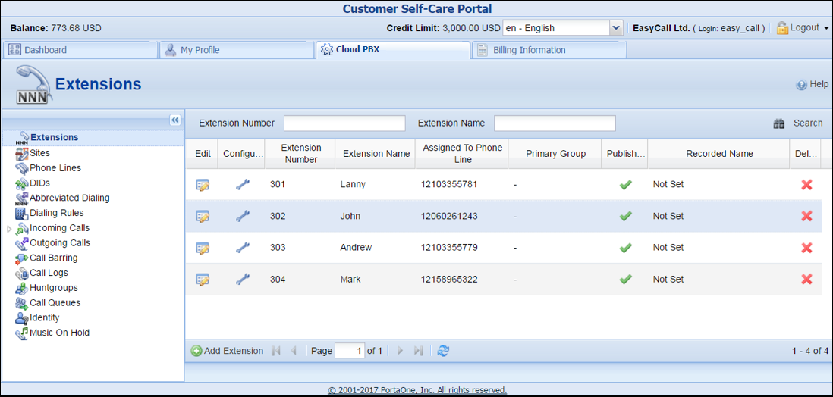
- Create the required extension (for example, 302 for account 12060261243).
- Set up the Auto Attendant option for a number (for example, 18005559876).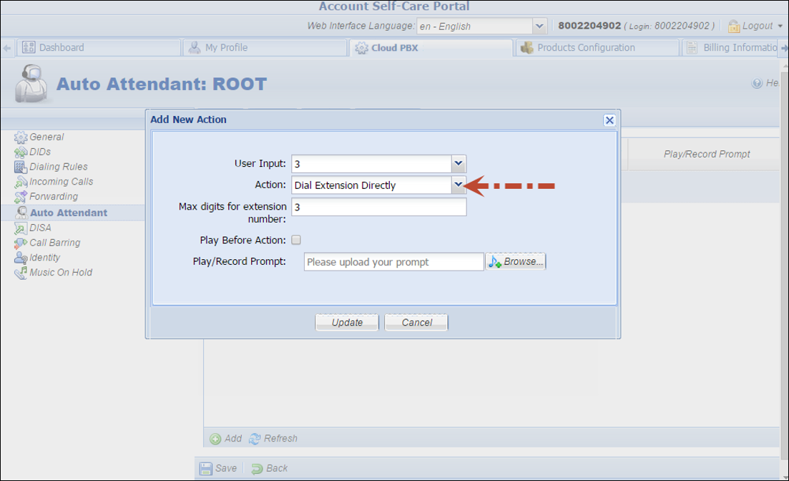
- Add the action Dial extension directly for event 3.
- When a caller dials 18005559876 and then 302, the call will be immediately redirected to John Doe (12060261243).
The feature is feasible when an extension number starts with the same digit as the "Dial extension directly" option (e.g., 3). Dial 301 but not 3-302, otherwise the extension won’t be found.
Disconnect calls to auto attendant
Link copied
Sometimes customers request that calls to their auto attendant be disconnected during non-working hours. For example: "TeenMuz," a local musical radio show for teenagers, has a separate line for callers to share their ideas or request a song while the show is live.
When the show is over and someone tries to get through, the caller hears a short message (e.g., "The show is over. Please call back tomorrow from 10:00 a.m.–12:00 a.m.") and then the call disconnects.
PBX customers can configure their auto attendant to play a prompt and disconnect a call when the menu is inactive or when the caller presses / does not press a key.
To configure the auto attendant to disconnect calls when the menu is inactive, a customer adjusts the auto attendant configuration on his self-care interface as follows:
- On the Auto Attendant page of the Cloud PBX tab go to the ROOT menu.
- For the When the menu is inactive, then: option, select Disconnect Call.
- Check the Play Before Action box.
- Upload or record a prompt to be played for the Upload/Record a prompt option and save the changes. 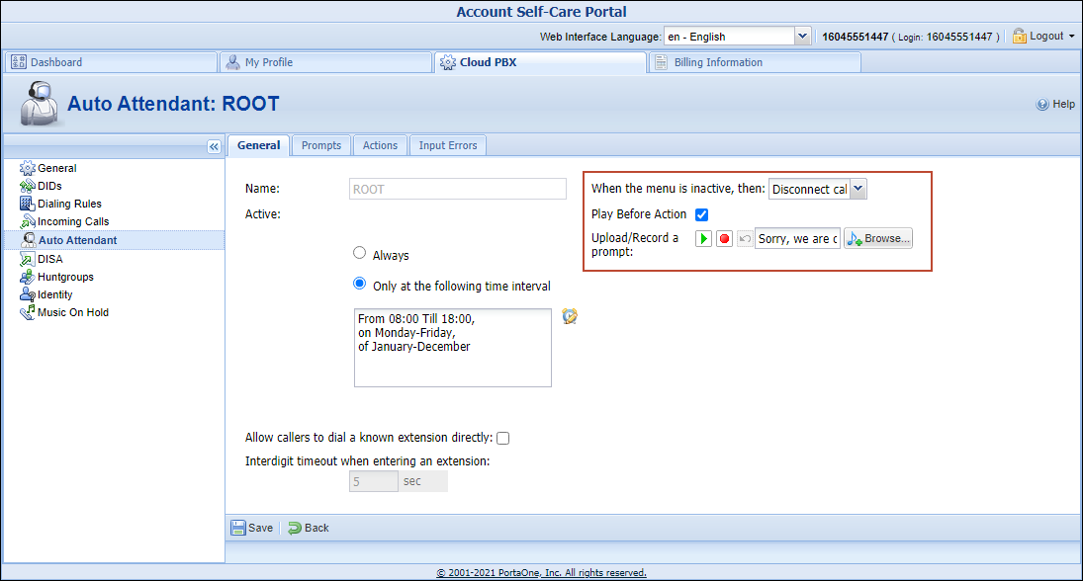
If a customer does not enable the Play Before Action option for the Disconnect Call action, the system will disconnect the call immediately after it has connected.
To configure the auto attendant to disconnect calls based on user input, a customer adds a new or adjusts the existing action. In our example we assume that the call must be disconnected if callers do not dial any key after they have listened to all menu options:
On the Actions tab of the necessary menu (e.g., ROOT) selects:
- User Input – No input.
- Timeout – 9.
- Action – Disconnect call.
- Play Before Action – checked.
- Play/Record Prompt – the prompt to be played.
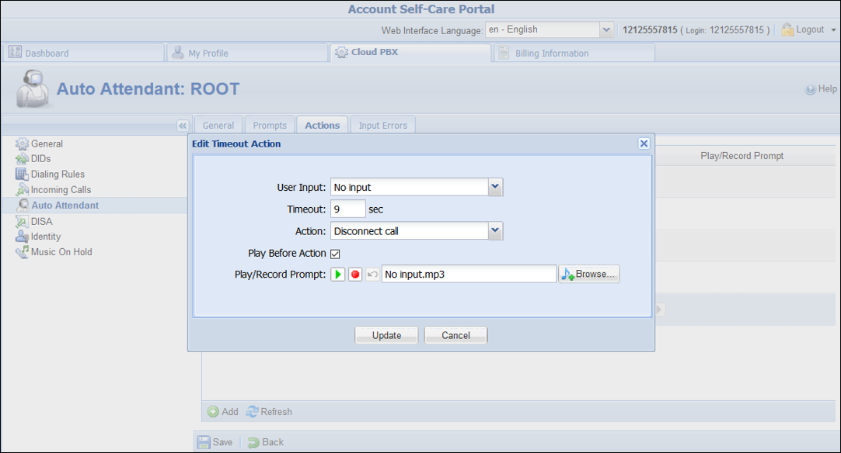
Bypass menu prompt to dial extension
Link copied
Your PBX customers can enable their callers to enter a party’s extension at any time once they are connected to a specific number. For instance, they can enter the extension number just after the greeting prompt or while the menu prompt is being played.
Let’s say that LCGold is a small local bank where 5 bank officers work. The bank consists of two departments: Retail Banking and Loan Operations.
The bank owner wants callers to hear "Welcome to LCGold. If you know your officer’s extension, please dial it. Press 1 to contact the Retail Banking department. Press 2 to contact the Loan Operations department," upon calling the bank number (e.g., 12125558715).
Then, when callers dial their officer’s extension, they will be immediately transferred to the officer’s phone.
To satisfy the customer’s requirements, an administrator creates 5 phone lines and an auto attendant with the 12125558715 number for the LCGold customer. The customer adds extensions on his web self-care interface, configures the call queues and then adjusts the auto attendant as follows:
- On the Auto Attendant page of the Cloud PBX tab opens the ROOT menu.
- On the General tab specifies when the ROOT menu is active and enables the Allow callers to dial a known extension directly option.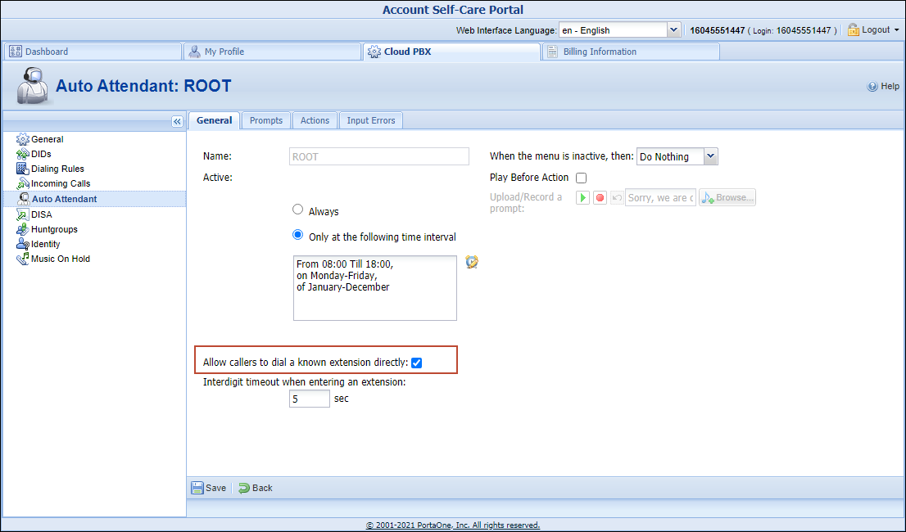
- Adjusts the Interdigit timeout when entering an extension option value. This is the maximum number of seconds the system waits till a user dials the second and following digits of an extension. This is used to define whether a user wants to enter an extension number or to select one of the menu options. For instance: Alice wants to reach her personal bank officer (ext. 2145) so she calls 12125558715. Once connected, she hears the greeting and starts to enter the extension number.After Alice has entered the first digit (2 in our example), the system starts the timer and waits 5 seconds for the next digit. Then:
  - If Alice does not remember the extension number and gives no input within this interval, the system considers the digit received to be a menu action and places Alice in the queue.
  - If Alice enters 1 within the next 5 seconds, the system considers the received digits to be a part of an extension number and restarts the timer. Alice enters the last two digits. If no input is received within 5 seconds, the system searches for the extension "2145" and connects the call.
 The default value for this option is 5 seconds. When changing this value, be advised that you should not slow down access to the menu actions, and should give callers enough time to enter the next extension digit.
- The customer defines the system’s behavior for the period during which the menu is inactive, uploads prompts, and configures actions to complete the configuration.

